🛡️ SpamGuard AI: The Intelligent Email Defense System

Version: 2.0 (Stable) | Stack: Python (FastAPI), JavaScript (Chrome V3), Gemini 1.5 Flash
📖 1. Project Overview
SpamGuard AI is a next-generation browser extension designed to protect Gmail users from the rising tide of sophisticated phishing, spoofing, and AI-generated spam. While traditional email filters effectively catch bulk spam, they often struggle with "context-aware" attacks—such as fake job offers, impersonated official notifications, or nonsensical bot traffic that bypasses standard keyword blocks.
To bridge this security gap, SpamGuard introduces a Hybrid Intelligence System that combines the speed of traditional Machine Learning with the cognitive reasoning of Large Language Models (LLMs). By operating directly within the browser, it provides real-time, second-layer verification without compromising user privacy.
Core Intelligence Layers:
- ⚡ Layer 1: Local Machine Learning (The Speed Filter)
  - A lightweight, pre-trained Scikit-Learn model runs instantly on the email text.
  - It rapidly flags high-probability spam patterns (e.g., "Urgent action required," "Lottery winner," "Verify password") with <50ms latency.
- 🧠 Layer 2: Generative AI Reasoning (The Context Judge)
  - Powered by Google Gemini 1.5, this layer acts as a cybersecurity analyst.
  - It verifies Sender Authenticity (e.g., ensuring a "PayPal" email actually comes from paypal.com).
  - It detects Semantic Anomalies (e.g., identifying "garbage text" like test_1_1 or incoherently broken sentences that simple filters might ignore).
- 🎨 Layer 3: User-Centric Experience
  - Non-Intrusive UI: A fully draggable, glass-morphic widget that floats over the Gmail interface, ensuring it never blocks vital information.
  - God Mode: Intelligently detects if an email is already in the Spam folder and adjusts its warning protocols to act as a second opinion rather than a redundant alert.

The Result: A proactive defence system that doesn't just block spam, but understands it.

🏗️ 2. System Architecture
SpamGuard operates on a "Split-Brain" architecture to ensure speed and privacy.
The Flow Diagram
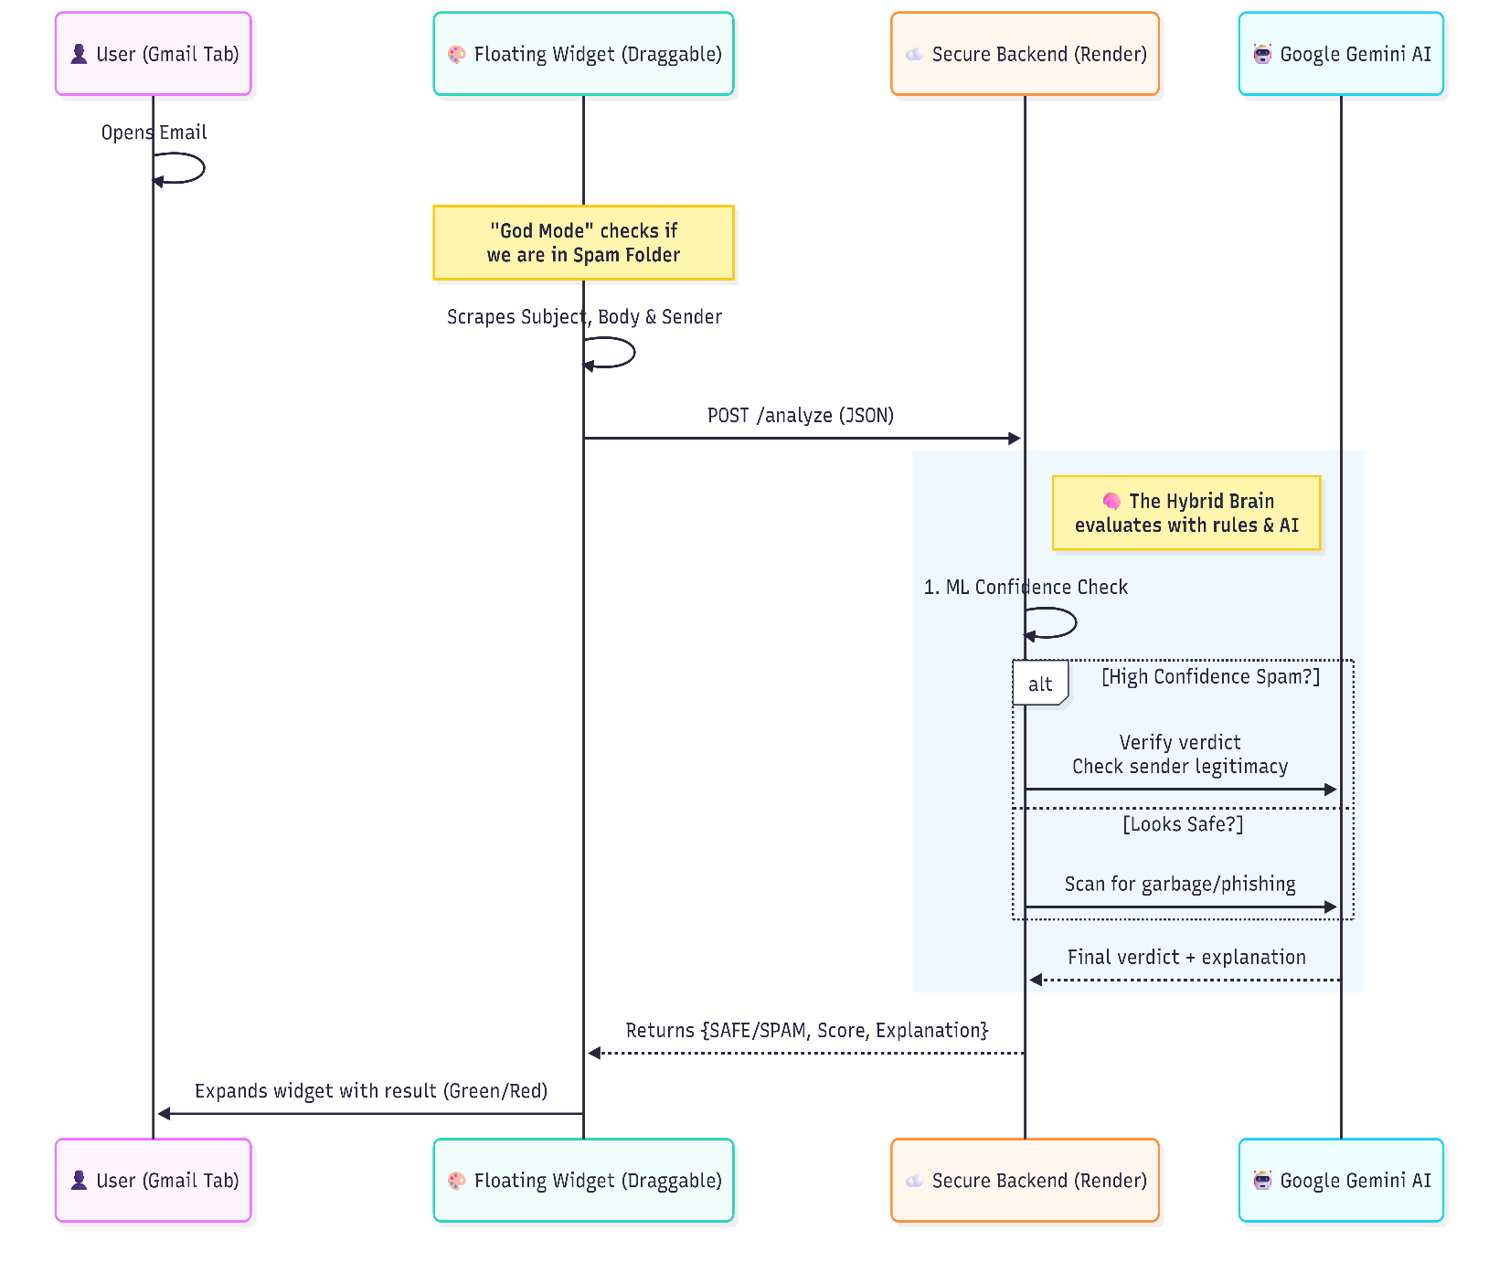

🌟 3. Key Features (The "Wow" Factors)
A. Smart UI (Draggable & Resizable)
- Movable Widget: Users can drag the widget anywhere on the screen so it never blocks the email content.
- Boundary Awareness: The code automatically detects screen edges. If expanding the widget would push it off-screen, it intelligently snaps back into view.
- Minimizable: Collapses into a small floating logo when not needed.
B. "God Mode" (Context Awareness)
- Spam Folder Detection: The extension knows when the user is looking at the Spam folder. If the AI thinks an email is "Safe" but Google put it in "Spam," the widget warns the user: "Google marked this as spam. Proceed with caution."
C. Anti-Spoofing (Sender Verification)
- Identity Check: The AI compares the Sender Address with the Email Content.
  - Example: If an email claims to be from "LinkedIn" but is sent by job-alerts@gmail.com, SpamGuard flags it immediately, even if the text looks real.

📂 4. Project File Structure
Here is a breakdown of the codebase for developers/evaluators:
Frontend (Chrome Extension)
- manifest.json → The configuration file (Permissions: ActiveTab, Storage).
- content.js → The Worker. Handles scraping Gmail, dragging logic, boundary checks, and API calls.
- popup.html / popup.js → The Remote. Handles the "Turn On/Off" master switch in the toolbar.
- style.css → The Look. Handles the glass-morphism effect, animations, and the "Movable" cursor logic.
Backend (Python/FastAPI)
- main.py → The Brain. Receives data, runs the ML model, constructs the Gemini prompts, and returns the verdict.
- model/spam_model_v2.pkl → The Muscle. A pre-trained Scikit-Learn model for fast keyword detection.

🚀 5. How to Run (Installation Guide)
1. Download
https://github.com/NiteshAnand190/SpamGuard-Client
- Download the file and Unzip it (Right-click Extract All). You should see a folder.
2. Install in Chrome
- Open Chrome and type this in the address bar: chrome://extensions
- Top right corner: Turn ON the switch that says "Developer mode".
- Top left corner: Click the button "Load unpacked".
- Select the folder you just unzipped.
That's it!
- Go to Gmail and refresh the page.
- You will see the SpamGuard logo in the bottom right corner.
- Note: Chrome might ask "Disable developer mode extensions?" when you restart the browser. Just click "Cancel" or "Keep changes" to keep using it.

❓ 6. Troubleshooting
- "Connection Refused": The backend (Render) might be sleeping. Wait 60 seconds and try again.
- "Widget Disappeared": Check the extension toolbar icon. Ensure the Master Switch is set to "Turn ON".
- "Off-Screen Widget": If the widget gets lost, just click the extension icon to toggle it Off and On again. It will reset to the bottom-right corner.

🔮 7. Future Roadmap (What's Next?)
We are constantly improving SpamGuard AI. Here are the features planned for v3.0:
- 📱 Mobile Integration: Extending support to the Gmail Android/iOS app via a companion analysis bot.
- 🏢 Enterprise Dashboard: A centralized admin panel for companies to track phishing attempts across all employee accounts.
- 🔗 Link Analysis: An advanced "Sandboxing" feature that opens suspicious links in a safe, isolated environment to check for malware before the user clicks.
- 🕸️ Dark Web Scan: Automatically checking if the sender's domain has been recently flagged on blacklists or dark web forums.

💻 8. Tech Stack Deep Dive
For the technical evaluators, here is exactly how we built it:
Component | Technology | Why we chose it?
Frontend Framework | Vanilla JS (ES6) | Lightweight and zero-dependency approach ensures the extension loads in <50ms without slowing down Gmail.
Styling | CSS3 Glassmorphism | Modern, translucent UI (backdrop-filter: blur) that feels native to the OS.
API Server | FastAPI (Python) | Chosen for its high performance (Starlette) and automatic Swagger UI documentation.
Machine Learning | Scikit-Learn | Uses a SGDClassifier trained on the Enron Email Dataset for sub-millisecond initial screening.
LLM Engine | Google Gemini 1.5 | The only model capable of handling large context windows (email headers + body) with high reasoning capabilities at low latency.
Hosting | Render Cloud | Provides automatic HTTPS/SSL encryption and scalable containerization (Docker).

🔒 9. Privacy & Security Policy
We believe security tools should not compromise privacy.
- Zero-Knowledge Architecture: We do not store your emails. The email body is sent to our RAM-only server, analysed, and immediately discarded.
- Transient Data: No database is connected to the content analysis engine. Once the verdict is returned, the data ceases to exist on our side.
- Open-Source Core: The client-side extension code is open for inspection, ensuring no hidden trackers or data siphoning scripts exist

